## INTRODUCTION

The technique of analyzing data to decide on the best course of action is known as prescriptive analytics. This kind of research produces suggestions for further actions by taking into account all pertinent elements. Prescriptive analytics is a useful tool for data-driven decision-making as a result.

Prescriptive analytics frequently use machine-learning algorithms to process enormous volumes of data more quickly—and frequently more effectively—than people. Algorithms search through data and offer suggestions depending on a particular set of requirements using "if" and "else" expressions. For instance, the algorithm may suggest extra training if at least 50% of customers in a dataset indicated that they were "extremely dissatisfied" with your customer support staff. Some examples of these prescriptive models are

* Venture Capital: Investment Decisions
* Sales: Lead Scoring
* Content Curation: Algorithmic Recommendations
* Banking: Fraud Detection

## PROBLEM STATEMENT

In this report, we will be using Prescriptive Modeling for Strategic Decision Making – Inventory Model which goes as follows -

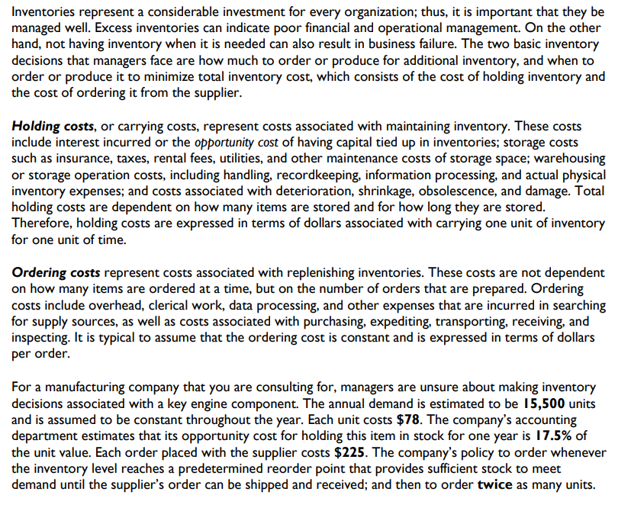

The following table is a generalization of the whole problem statement.

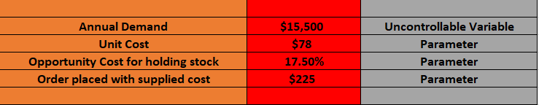

Making a decision model is necessary because we must provide the client with the best possible answer.

## ANALYSIS

## Part One: Excel & R based Consulting.

## (1) Describe the data, uncontrolled variables, model parameters, and decision variables that have an impact on the overall cost of the inventory.

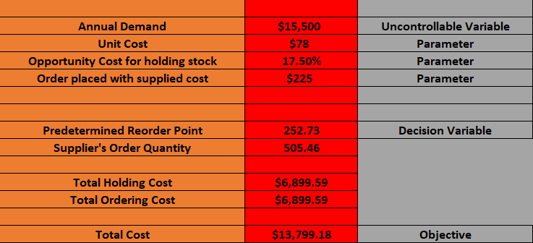

Our objective is the Total Cost and our Decision Variable is the Predetermined Reorder Point value. Our model parameters are unit cost, opportunity cost & order placed while the uncontrollable variable is the annual demand.

## (2) Create mathematical formulas that calculate the yearly holding cost and the annual ordering cost based on the average inventory held over the course of the year, then use them to create a mathematical model for the annual cost of all the inventory.

The number of times orders are placed and the cost of each order are the two parameters that have an impact on annual ordering costs.

Annual Ordering Cost = Number of times an order has been placed *Cost associated with each order

The holding costs of each item in a single order, the number of days it takes to sell a new order, and the number of times the order has been made are the three elements that have an impact on annual holding costs.

Annual Holding Cost = Holding cost of each item in a single order * No. of days to sell new order * No. of times the order has been placed.

## (3) Using an Excel spreadsheet to implement the model.

To minimize the cost and determine the order quantity, we used Excel's solver feature.

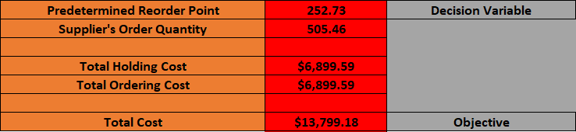

As can be seen from the above result, the Predetermined Reorder Point after calculations is 252.73, indicating that the inventory level may reach a maximum of 253 units. Additionally, the supplier's order quantity equals 505.46, which indicates the approximate number of items to order in order to keep the cost of the inventory benefit of the entire low. The total cost for the items mentioned is $13,799.18.

The order quantity affects how the total cost is calculated.

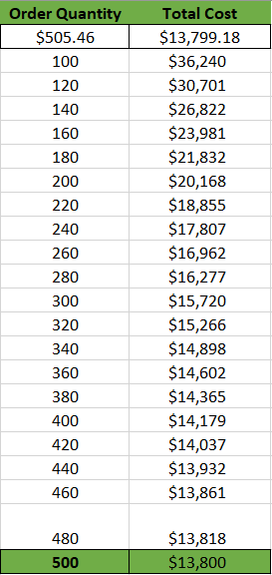

The minimal value for the total cost, which is in the 400–600 range, may be predicted from the graph above. We can calculate the precise order quantity and total cost using the solver, and they are 505.46 and 13799.18, respectively.

## (4) Using R now to implement the same model.

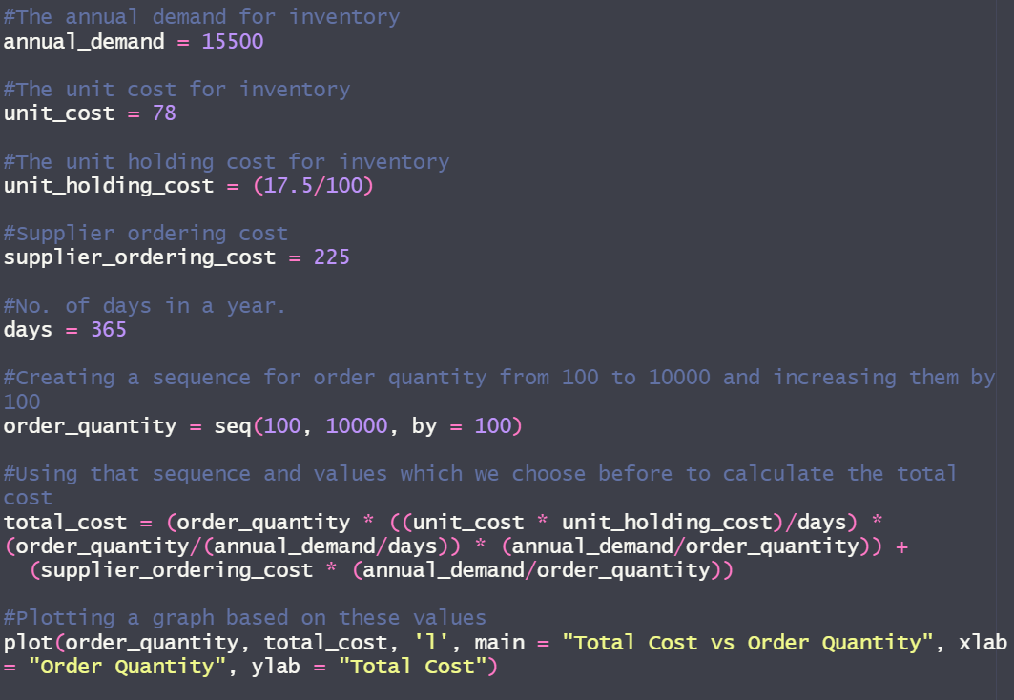

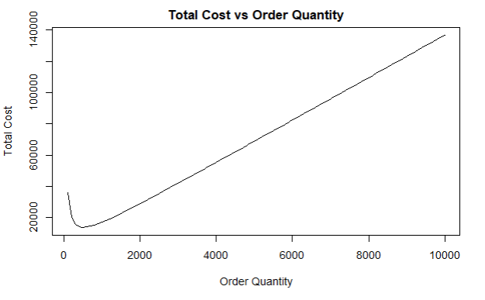

We created a total cost versus order quantity graph in R and input the numbers to compare it to our excel graph. From this, we can see that the graphs are very comparable. This graph differs from the one we created in Excel in that we specified a range of 10,000 instead of 1800. It's a little challenging to determine the minimum total cost depending on the order quantity from this graph.

Therefore, we will Zoom in on the graph and figure out the value from there. We can do that by reducing the range and using the same code which we used above. Here the range we used was between 300 to 700.

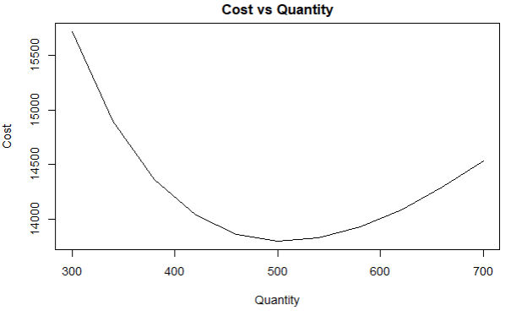

The minimum order quantity is around 500, and the overall cost is under 14,000, as may be seen below. We calculated the minimal value using R's which.min function, and then we used indexing to obtain the minimum order quantity of 500 and the total cost of 13800, respectively.

## (5) Optimization Using R.

The best minimal value was obtained using the R's built-in optimize function. To calculate the overall cost for that value, we applied the identical formulas as in the prior work and saved the results as a function. Using it, we obtained our optimal value.

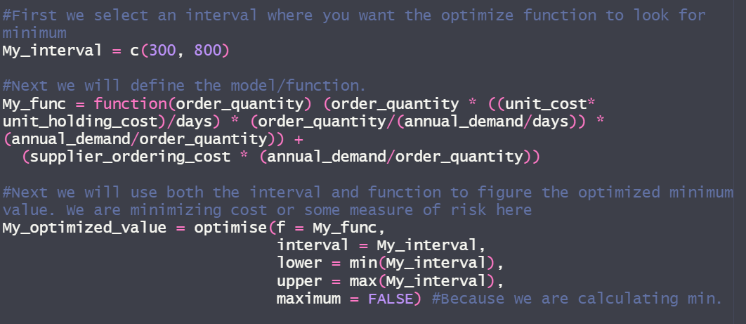



We can see that the optimized minimum total cost and order quantity are comparable to the results we obtained using the Excel solver.

## (6) Sensitivity Analysis.

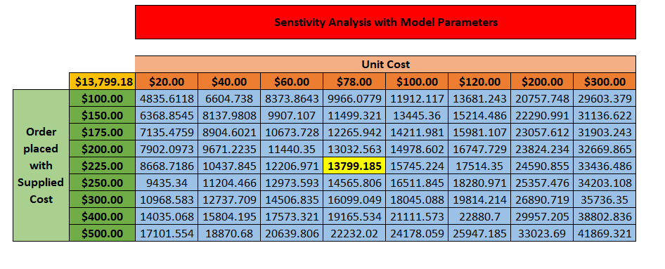

After receiving our model, we performed sensitivity analysis on it and what-if analysis on the unit cost and provided ordering cost. Using a data table for numerous unit costs and provided ordering costs, we were able to generate one that included both unit costs and supplied ordering costs. To double-check, we compared our $78 unit cost with the $225 ordering cost that we were given, and the result was 13799.18. For other values, we similarly produced a table. For example, if the provided cost is $400 and the unit cost is $120, the result is 22880.7.

So, in the end, we can state that as the unit price increases, so does the total provide ordering cost. As a consultant, I would advise the team to place a new purchase for twice that amount once the inventory reaches roughly 225 in order to lower the company's predicted $13,799.18 annual total cost.

## Part Two: Using R for Triangular Probability Distribution.

Assume that all the variables in the problem are the same as they were in part one, except that the annual demand has a triangular probability distribution with a range of 12000 to 18000 units and a mode of 16000 units.

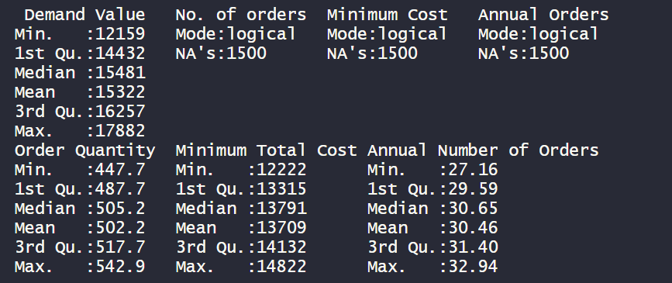

We utilized the optimized R function to obtain the simulated matrix result and the summary function to express it in the summary function after computing the triangular probability distribution in R for the aforementioned values. Here, we discover that the mean order quantity is 502.2 and the mean total cost is 13709. We can see that the median values for the order quantity and total cost are pretty similar to the ones we previously got in R and Excel.

## (1) Checking the best fit distribution for minimum total cost.

1500 random variables have been acquired for the modeling process, along with the lower, higher, and peak demand figures.

We plotted the Weibull, gamma, normal and uniform graph for minimum total cost.

**Weibull plot**

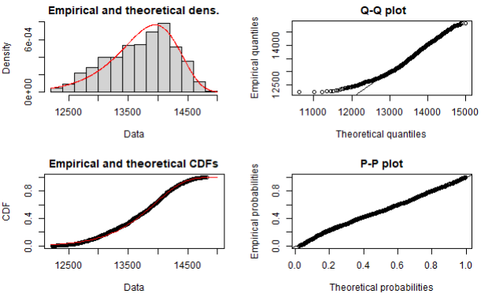

**Gamma plot**

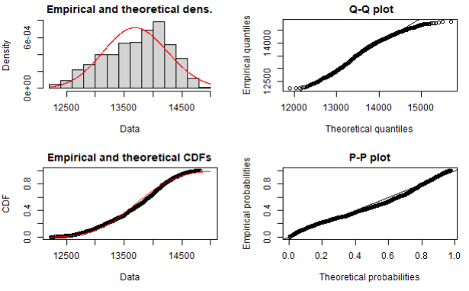

**Normal plot**

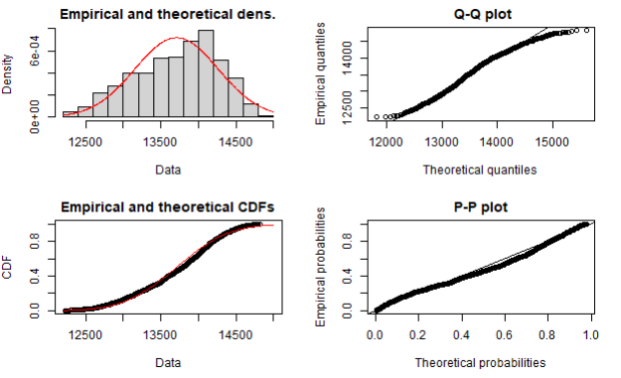

**Uniform distribution plot**

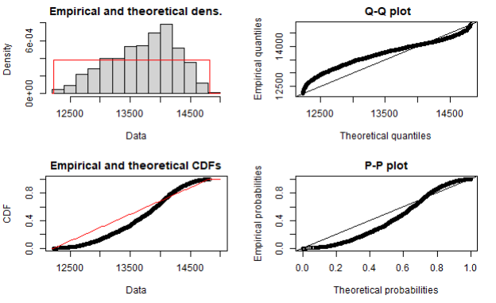

Next, we perform Shapiro Test to find out the distribution for minimum total cost.

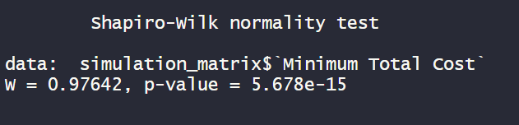

Since the pvalue is less than 0.05, we have sufficient evidence to say that the sample data does not come from a population that is normally distributed.

## (2) Checking the best fit distribution for order quantity.

We plotted the Weibull, gamma, normal and uniform graph for order quantity.

**Weibull plot**

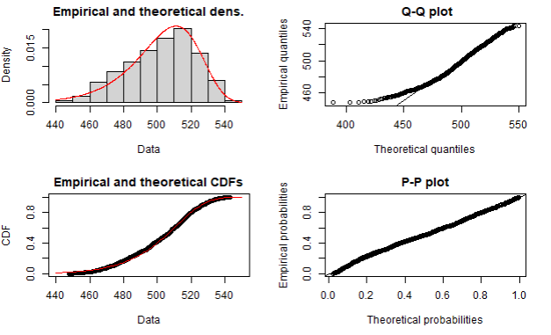

**Gamma plot**

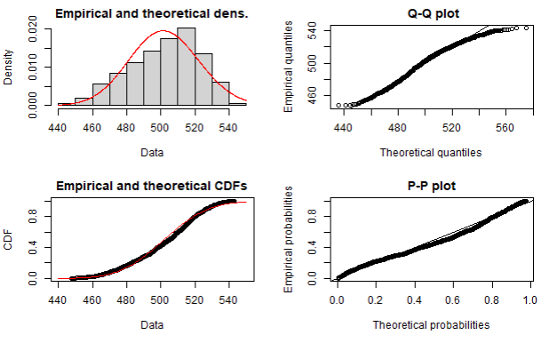

**Normal plot**

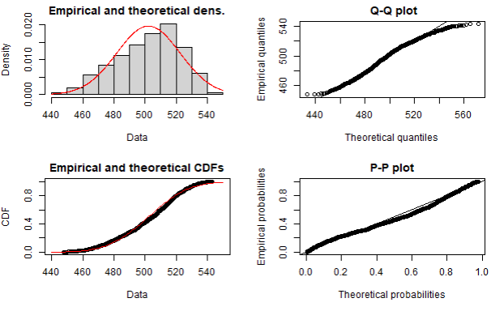

**Uniform distribution plot**

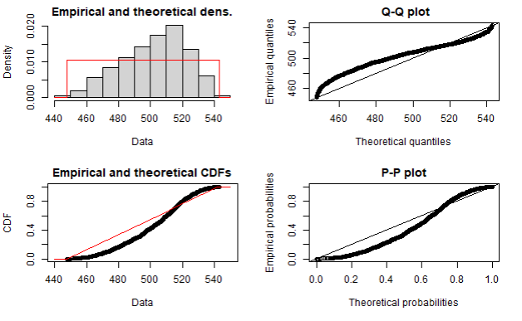

Next, we perform Shapiro Test to find out the distribution for order quantity.

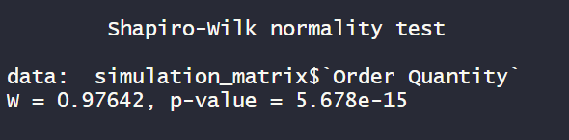

Since the pvalue is less than 0.05, we have sufficient evidence to say that the sample data does not come from a population that is normally distributed.

## (3) Checking the best fit distribution for annual number of orders.

We plotted the Weibull, gamma, normal and uniform graph for annual number of orders.

**Weibull plot**

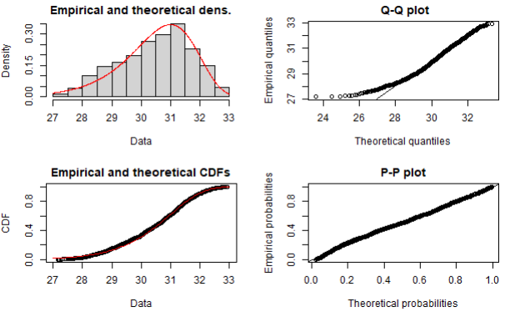

**Gamma plot**

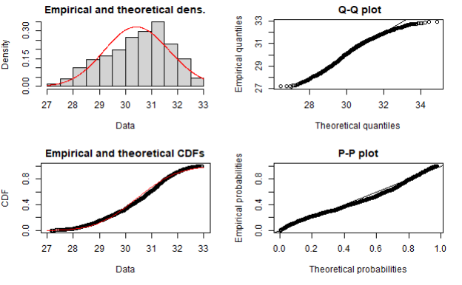

**Normal plot**

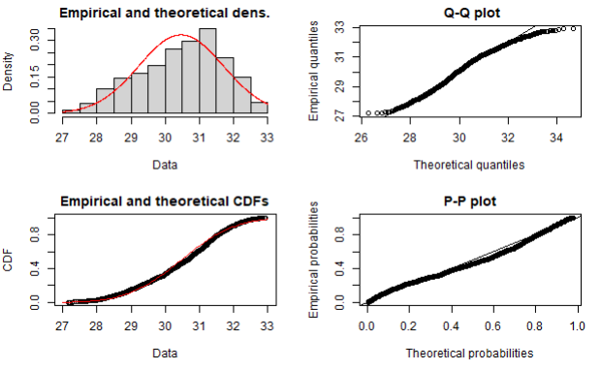

**Uniform distribution plot**

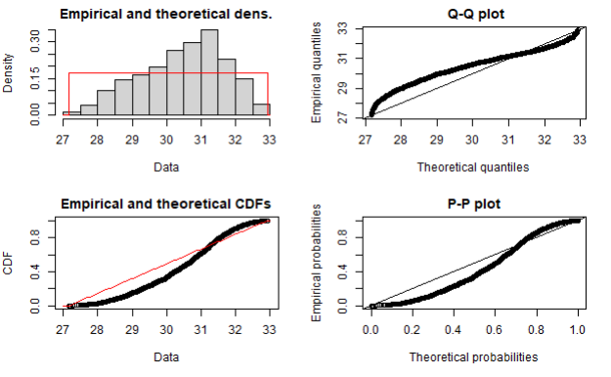

Next, we perform Shapiro Test to find out the distribution for annual number of orders.

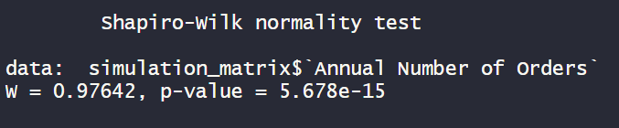

Since the pvalue is less than 0.05, we have sufficient evidence to say that the sample data does not come from a population that is normally distributed.

## CONCLUSION

Working on a real-world inventory-based model allowed me to finally understand about decision-making models. While developing this model, I gained knowledge of the model's parameters, uncontrolled variables, decision variable, and purpose. I also discovered how to utilize Excel's solver to determine the ideal minimum total cost number. The same model building process and how to obtain the optimum value in R were also things I learnt. Furthermore, I discovered how to use R's triangular probability distribution and apply that simulation to obtain the values. Along with that, I learnt about the fitdistrplus and logspline libraries in R and used them to find the distribution that best fits all of the values, where I learned about Weibull, gamma, norm, and unif plots. Finally, I discovered how to utilize Excel's sensitivity analysis to obtain various results when the variable values changed. In the end, as a consultant, I would advise the vice president of operations that all three distribution types' model parameters have been established, and that all three distribution types are not Normally Distributed.

## REFERNCES

1) Cote, C. (2021, November 2). What Is Prescriptive Analytics? 6 Examples | HBS Online. Business Insights Blog. https://online.hbs.edu/blog/post/prescriptive-analytics

2) Excel Solver Tutorial - Step by Step Easy to use guide for Excel’s Solver. (2020, December 21). Solver. https://www.solver.com/solver-tutorial-using-solver

3) Z. (2021, December 3). How to Use the Triangular Distribution in R (With Examples). Statology. https://www.statology.org/triangular-distribution-in-r/

4) RPubs - FitDistrPlus Overview. (2018, December 10). rPubs. https://rpubs.com/blakeobeans/fitdistrplus